The 3 functions I picked from W3Schools was

1. **MySQL UNION Operator**

* Provide an explanation of when it might be used.
  + I imagine you would use this in a system that tracks people and change it when they come together for example if two people were to get married or if two people stay working as a team you can track all these changes in a system using the UNION Operator.
* Provide the SQL statement, run the statement, then take a screenshot of the results and paste it into your Word document.
  + 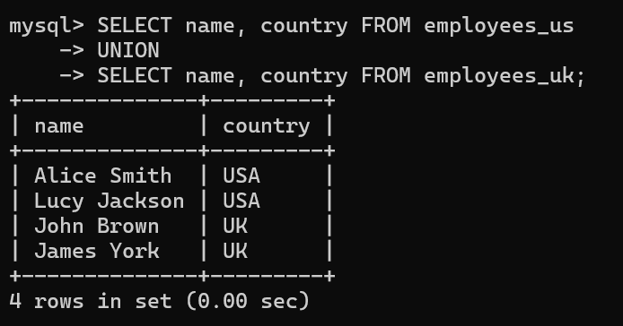

1. **The MySQL LIMIT Clause**

* Provide an explanation of when it might be used.
  + If you had a database with a lot of different values like employees you can use the LIMIT Clause to select a certain amount you only want to see.
* Provide the SQL statement, run the statement, then take a screenshot of the results and paste it into your Word document.
  + 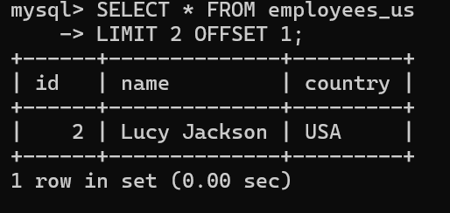

1. **The MySQL DELETE Statement**

* Provide an explanation of when it might be used.
  + You would use the DELETE Statement when you want to delete a row from a table like an employee for example.
* Provide the SQL statement, run the statement, then take a screenshot of the results and paste it into your Word document.
* 